Title: | Web Servers and Database Fundamentals
Updated: | April 3, 2025 | Due Date: | Midnight before the next class meeting.
Purpose: | The purpose of this lab is to develop foundational skills in deploying and managing web and database servers within containerized environments, using Docker to enable scalability, data persistence, and seamless server communication.  This lab addresses competencies 3 - utilize a web server, 4 - identify database fundamentals, and 5 - install and use containers.
Knowledge: | After completing this lab, you will understand how to deploy, configure, and integrate web and database servers using Docker containers with persistent storage and network connectivity.
Task/Activity: | A. AWS Academy Instance Prep  B. Databases with Docker  C. Web Servers with Docker  D. Connecting Web and Database Containers Together  E. Reflection
Criteria for Success: | Success in this lab is marked by accurate task completion, effective analysis, documentation, and clear communication of findings. A crucial aspect involves reflecting on the purpose of the lab, linking procedures to broader concepts, and recognizing the lab's significance within the course.  Overall, success is not only measured by technical proficiency but also by critical thinking, effective communication, and a reflective summary that captures the challenges faced and insights gained throughout the lab experience.
- AWS Academy Instance Prep
Because the containers that we are going to use are a bit more resource intensive than the previous labs, we are going to have to change the instance type for our DevOps server.
- Navigate to your DevOps instance in the AWS dashboard.
- Select your instance and then click “Instance state” at the top.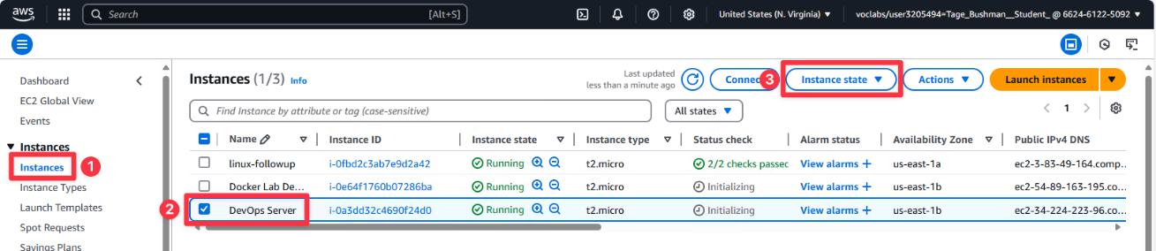
- Select “Stop instance” then “Stop.”
- Once stopped (which may take a little while), select “Actions” -> “Instance settings” -> “Change instance type.”
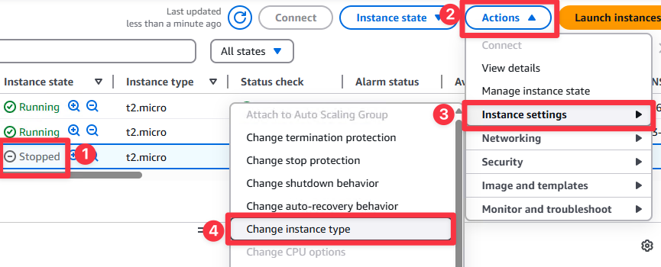
- Under “New instance type,” type in “t2.medium.” This will increase the processor to 2 cores (up from 1) and the memory from 1GB to 4GB, which is needed for the database server.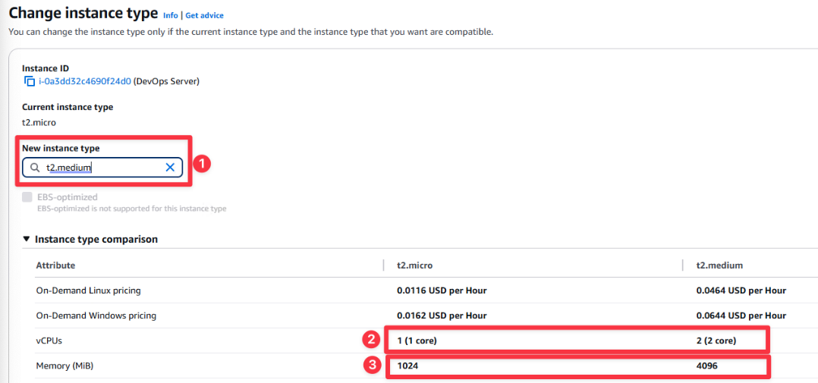
- Scroll to the bottom and select “Change.”
- Back on the instances list, make sure your instance now says “t2.medium” under “Instance type” in the list, then select “Instance state” -> “Start instance.” You are now ready to complete this lab.
- Databases with Docker
In the last lab, we learned how to use Docker to download and run containers. We are going to take that a step further and run a database server in a container.
To do this, a MySQL image needs to be run.
# docker pull mysql:latest ß This will pull the latest version of the MySQL image from DockerHub.
Now we can start the container detached (-d), giving it a name (--name), and specifying a password using the environment (-e) variable flag to specify the MYSQL_ROOT_PASSWORD setting. (Variables like this can be seen in the DockerHub page for the image https://hub.docker.com/_/mysql):
# docker run --name mysql-server -e MYSQL_ROOT_PASSWORD=student99 -d mysql:latest
The MySQL server should be running now. Verify this with docker ps.
# docker ps
CONTAINER ID IMAGE COMMAND CREATED STATUS PORTS NAMES
d5f16f36ecf4 mysql:latest "docker-entrypoint.s…" 3 seconds ago Up 2 seconds 3306/tcp, 33060/tcp mysql-server
Now that you can see the container is running, we can connect to it and run SQL queries:
# docker exec -it mysql-server mysql -uroot -p
This command will allow you to login to the container interactively (exec -it) and run the mysql command in the container (mysql) as the root user (-uroot) and ask you for the MySQL root password (-p). Enter the password you specified in the docker run environment variable (-v).
Enter password: student99
Welcome to the MySQL monitor. Commands end with ; or \g.
Your MySQL connection id is 9
Server version: 9.2.0 MySQL Community Server - GPL

Copyright (c) 2000, 2025, Oracle and/or its affiliates.

Oracle is a registered trademark of Oracle Corporation and/or its
affiliates. Other names may be trademarks of their respective
owners.

Type 'help;' or '\h' for help. Type '\c' to clear the current input statement.

mysql>
Since we are connected to the database server now, we can run SQL commands. Start with listing the databases on the server:
mysql> show databases;
+--------------------+
| Database |
+--------------------+
| information_schema |
| mysql |
| performance_schema |
| sys |
+--------------------+
4 rows in set (0.01 sec)
We will use the mysql database to run some easy queries.
mysql> use mysql;
Reading table information for completion of table and column names
You can turn off this feature to get a quicker startup with -A

Database changed
List the tables in the mysql database.
mysql> show tables;
+------------------------------------------------------+
| Tables_in_mysql |
+------------------------------------------------------+
| columns_priv |
| component |
| db |
| default_roles |
| engine_cost |
| func |
| general_log |
| global_grants |
| gtid_executed |
| help_category |
| help_keyword |
| help_relation |
| help_topic |
| innodb_index_stats |
| innodb_table_stats |
| ndb_binlog_index |
| password_history |
| plugin |
| procs_priv |
| proxies_priv |
| replication_asynchronous_connection_failover |
| replication_asynchronous_connection_failover_managed |
| replication_group_configuration_version |
| replication_group_member_actions |
| role_edges |
| server_cost |
| servers |
| slave_master_info |
| slave_relay_log_info |
| slave_worker_info |
| slow_log |
| tables_priv |
| time_zone |
| time_zone_leap_second |
| time_zone_name |
| time_zone_transition |
| time_zone_transition_type |
| user |
+------------------------------------------------------+
38 rows in set (0.00 sec)
Now we can query one of the tables.
mysql> select * from tables_priv;
+-----------+-------+---------------+------------+----------------+---------------------+------------+-------------+
| Host | Db | User | Table_name | Grantor | Timestamp | Table_priv | Column_priv |
+-----------+-------+---------------+------------+----------------+---------------------+------------+-------------+
| localhost | mysql | mysql.session | user | boot@ | 2025-01-30 17:23:14 | Select | |
| localhost | sys | mysql.sys | sys_config | root@localhost | 2025-01-30 17:23:14 | Select | |
+-----------+-------+---------------+------------+----------------+---------------------+------------+-------------+
2 rows in set (0.00 sec)
Now that we have poked around, lets disconnect.
mysql> exit;
We now know we have a working database server running in an instance. The only problem is when we make any updates or changes to the database, it will not be saved if we remove the container. We should either bind mount a host folder to the container or use a Docker volume. For our use case, we will use a volume.
# docker volume create mysql-data
Stop the mysql-server container and remove it since we will need to recreate it with the volume mapping.
# docker stop mysql-server
# docker rm mysql-server
Recreate the mysql-server container
# docker run --name mysql-server -e MYSQL_ROOT_PASSWORD=student99 -v mysql-data:/var/lib/mysql -d mysql:latest
The MySQL container is now running and storing the database data in the mysql-data volume. We can test this by going into the container, creating a new database, stopping and deleting the container, and then recreating the container mapping the mysql-data volume and verifying that the new database is still there.
# docker exec -it mysql-server mysql -uroot -p
mysql> show databases;
+--------------------+
| Database |
+--------------------+
| information_schema |
| mysql |
| performance_schema |
| sys |
+--------------------+
4 rows in set (0.00 sec)
mysql> create database labtest;
mysql> show databases;
+--------------------+
| Database |
+--------------------+
| information_schema |
| labtest |
| mysql |
| performance_schema |
| sys |
+--------------------+
5 rows in set (0.00 sec)
mysql> exit;
# docker stop mysql-server
# docker rm mysql-server
# docker run --name mysql-server -e MYSQL_ROOT_PASSWORD=student99 -v mysql-data:/var/lib/mysql -d mysql:latest
# docker exec -it mysql-server mysql -uroot -p
mysql> show databases;
+--------------------+
| Database |
+--------------------+
| information_schema |
Still there!
| labtest |
| mysql |
| performance_schema |
| sys |
+--------------------+
5 rows in set (0.00 sec)
Notice that even though we have deleted the docker container, since the database information is stored in the volume, it shows up in the new container mounted in the same way. This must be done to persist data between containers.
For a future step, a new database needs to be created.
mysql> create database wordpress;
Disconnect from the container.
Run docker container inspect to get the IP address of the mysql-server container.
# docker container inspect mysql-server
"Networks": {
"bridge": {
"IPAMConfig": null,
"Links": null,
"Aliases": null,
"MacAddress": "02:42:ac:11:00:02",
"DriverOpts": null,
"NetworkID": "87e4a4b884818a173f561e7b7dd31c8506c644166ea4ede46a0950395886b494",
"EndpointID": "466bc1c54e44a723bc8b465cc9bab93ea985dd2435317f1428e1c43878fb3131",
"Gateway": "172.17.0.1",
"IPAddress": "172.17.0.2",
Container IP Address
"IPPrefixLen": 16,
"IPv6Gateway": "",
"GlobalIPv6Address": "",
"GlobalIPv6PrefixLen": 0,
"DNSNames": null
}
Note this IP address, you will need it in section C.
172.17.0.2
- Web Servers with Docker
Now that there is a database server setup, we can launch a web server container. Using the information from the previous lab, and from part A above, create a volume called nginx-data and launch a nginx container named nginx-server, mapping the volume to /usr/share/nginx/html and mapping port 8080 to port 80 on the container.
When launched, the output of docker ps should match this:
CONTAINER ID IMAGE COMMAND CREATED STATUS PORTS NAMES
aa991fc179b2 nginx "/docker-entrypoint.…" 6 seconds ago Up 6 seconds 0.0.0.0:8080->80/tcp nginx-server
If this is not the case, please delete the container and try again after reviewing step A and the previous lab.
Go into the container.
# docker exec -it nginx-server bash
root@aa991fc179b2:/#
For the next section, the vim (vi improved) tool is needed. Update the repository database.
root@aa991fc179b2:/# apt update
Install vim.
root@aa991fc179b2:/# apt install -y vim
Navigate to the folder where we mounted the nginx-data volume to inside of the container (hint: from your docker run command).
root@aa991fc179b2:/# cd {path here}
Edit the index.html file.
root@aa991fc179b2:/{path here}# vim index.html
Add something to the HTML file and save it. (i for insert, make changes, esc to exit insert mode, :wq to write and quit).
Browse to the nginx server in your browser using your public DNS address from the AWS console, using HTTP port 8080.
http://ec2-100-26-134-138.compute-1.amazonaws.com:8080/
Provide the screenshot of the edited page in the browser.
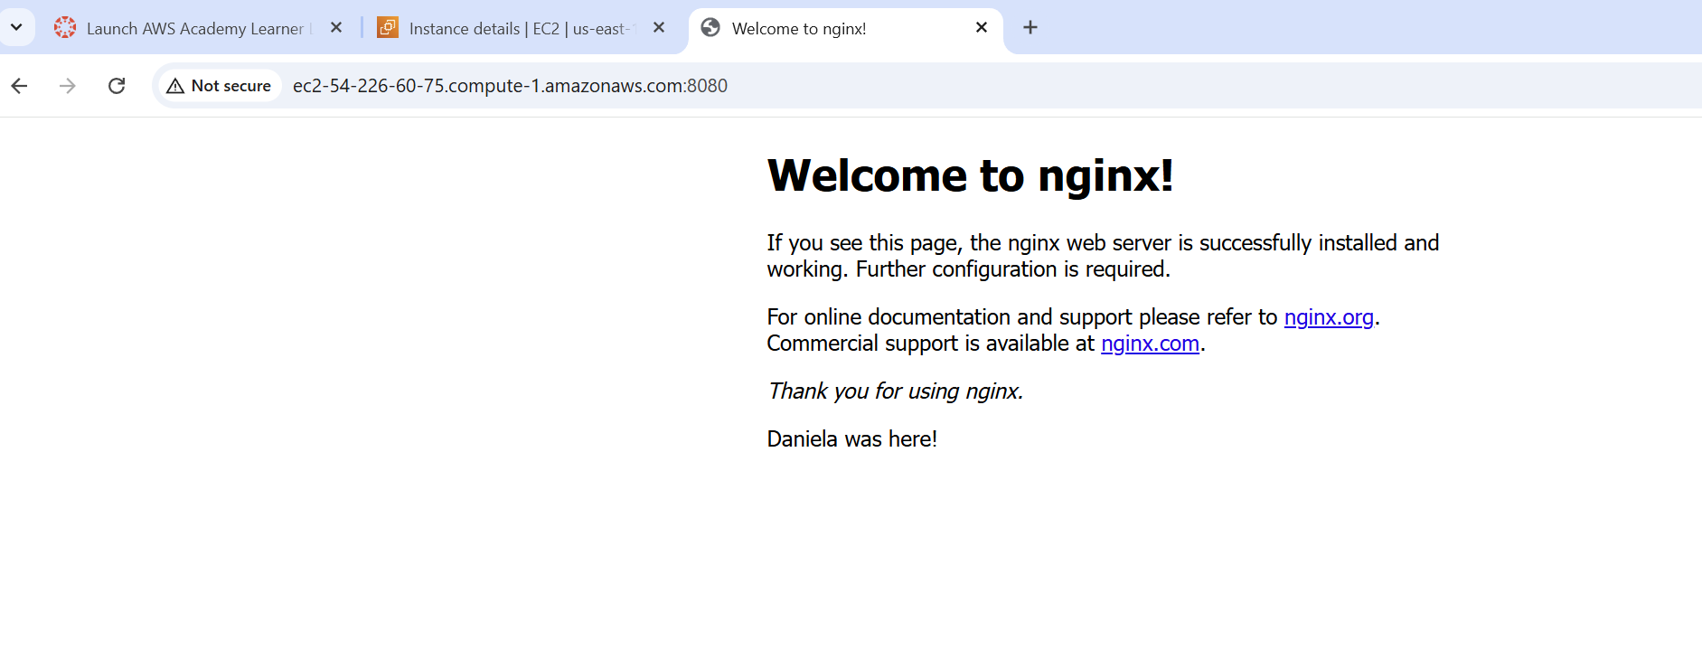
The index.html file that you edited is stored in the nginx-data volume created earlier.
- Connecting Web and Database Containers Together
We have both parts of a functional web server at this point, but for the next step, we need to wrap PHP into the nginx container. We could build one ourselves, but we can also use one that is already built for this.
Download the trafex/php-nginx image and run it with the same configuration as the nginx server we just created in step B. Don’t forget to stop and delete the previous container.
Note: The path in the container needs to be changed from /usr/share/nginx/html to /var/www/html with the extra :rw after the container path (-v volume:/path/to/folder:rw) and the port on the container is 8080.
To get into this container, the command is slightly altered.
# docker exec -it nginx-server sh ß Notice it is just sh and not bash as before. This container uses sh instead
/var/www/html $
The prompt on this one looks different too, because sh is a different shell than bash, we just have the path, which conveniently is /var/www/html where we need to put files to be served by nginx.
Download the WordPress compressed file from our Western site:
/var/www/html $ wget https://f005.backblazeb2.com/file/webandsoftware-online/devops/docker/wordpress-6.7.1.tar.gz
Extract the files with the tar command.
/var/www/html $ tar -xzvf wordpress-6.7.1.tar.gz
This has expanded all the files needed for WordPress to run. Browse to your AWS DNS address from the AWS console and navigate to port 8080 and subdirectory wordpress, which we just extracted.
http://ec2-100-26-134-138.compute-1.amazonaws.com:8080/wordpress/
This should present you with the installation wizard. Click “Let’s go!” at the bottom to start the setup.
This is where WordPress will be configured to talk to the database container. Enter the settings as follows:
Database Name | wordpress (the database you created in A)
Username | root (the MySQL Server user)
Password | student99 (the MySQL Server user password)
Database Host | 172.17.0.2 (the IP Address you got in part A for container mysql-server - yours may be different)
Table Prefix | wp_
Click “Submit.” Click “Run the installation.”
Configure the site settings:
Site Title | Whatever you want.
Username | Your Name
Password | Choose one or accept the generated on. Make a note of this. Password: Here
Your Email | Can be your student or personal email.
Search engine visibility | Unchecked
Click “Install WordPress.”
Login with your username and password you specified in the setup. Paste the screenshot below of the dashboard.
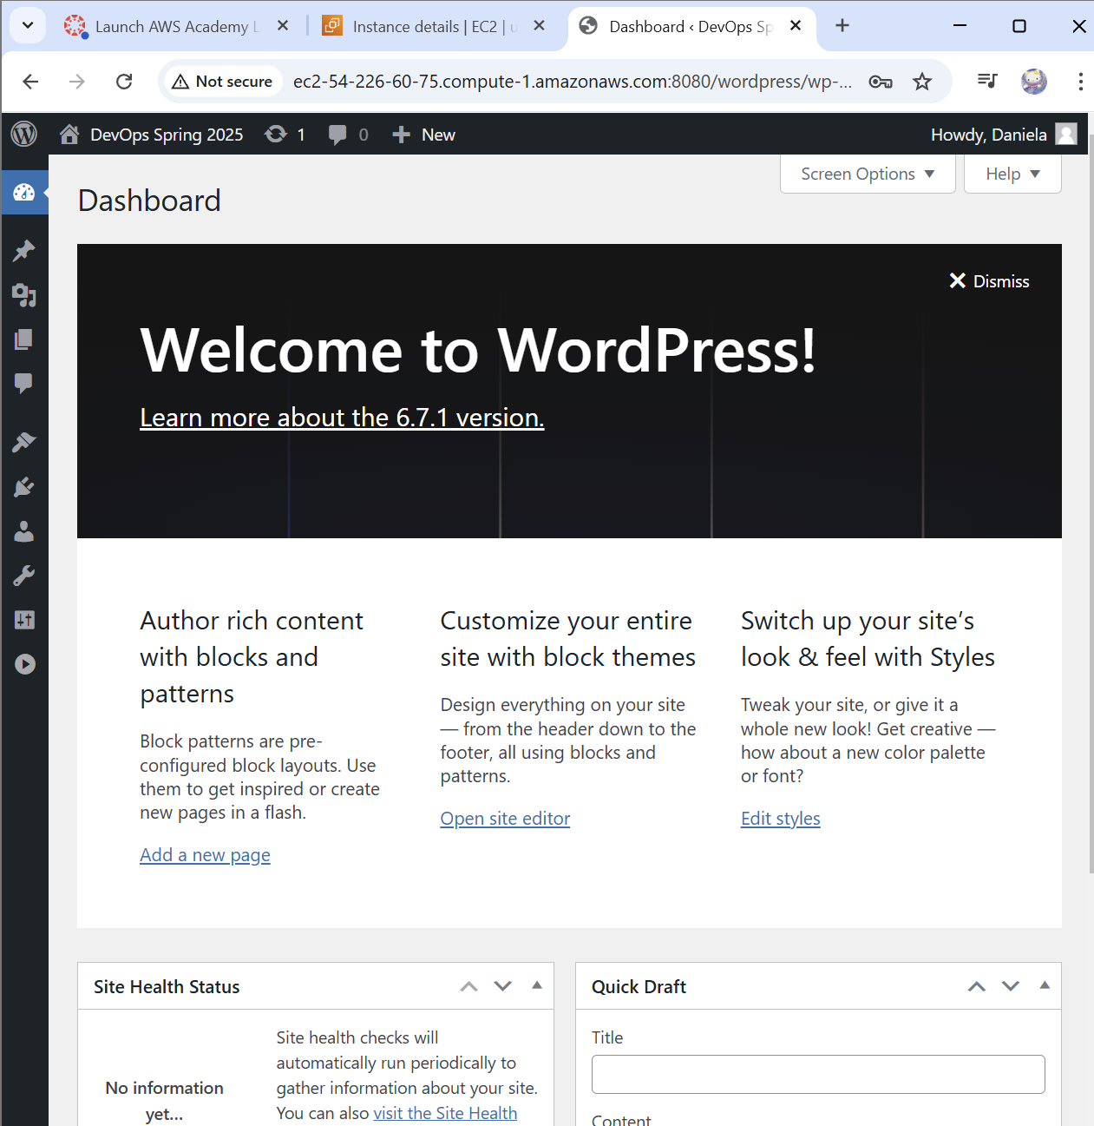
Congratulations! Your web server container has connected to your database container!
IMPORTANT: When you are done with this lab, go back to the setup (part A) and set your instance back to a t2.micro instance type.
- Reflection
Reflect on your experience setting up and configuring both the MySQL and Nginx servers using Docker containers. Consider the challenges you faced while creating and persisting databases and the process of linking web and database containers. How has this lab enhanced your understanding of containerized environments, data persistence, and server integration?
Through this lab I noticed that I have to be very careful with how I set up my code. There is a lot of room for minor errors that could cause your code to not work, for example typos. When working through the MySQL server and Nginx servers, I noticed that there were a lot of similarities in how the setup is run, that when prompting new containers and volumes we really need to be careful with it. Like always it was exciting to see the changes we can make in the terminal and how they affect the browser.

